Section 1: Child Population Projections

ONS Mid-Year Estimates (MYE)
Mid-year population estimates relate to the usually resident population. They account for long-term international migrants (people who change their country of usual residence for a period of 12 months or more) but do not account for short-term migrants (people who come to or leave the country for a period of less than 12 months).

Harrow’s 2020-MYE
According to the 2020-MYE Harrow’s school age children are estimated to have increased from 2019 to 2020, whilst the pre-school and post-school numbers have decreased, as can be seen in the table below.

Age | mid-2019 | Mid-2020 | # change | % change
0 to 4 | 17,842 | 17,832 | -10 | -0.06%
5 to 9 | 17,137 | 17,429 | 292 | 1.70%
10 to 14 | 15,333 | 15,552 | 219 | 1.43%
15 to 19 | 13,644 | 13,951 | 307 | 2.25%
20 to 24 | 13,039 | 12,889 | -150 | -1.15%
Source: Population Estimates Table (2020)

ONS Sub National Population Projections
The ONS’s Population Projections (SNPP) provide statistics on potential future size and age structure of the population. They are based on past trends and assumptions of future levels of births, deaths and migration. They do not incorporate local development plans but instead provide a baseline, which can be combined with local knowledge.

Harrow’s 2018-based SNPPs
According to the ONS’s SNPPs Harrow’s primary age children from 0 to 4 and 5 to 9 are projected to decrease between 2018 and 2028.

According to the ONS’s SNPPs Harrow’s secondary age children from 10 to 19 are projected to continue increasing;

Age range | 2018 | 2023 | 2028 | # change 2018-2028 | % change 2018-2028
0-4 | 17,745 | 15,732 | 14,840 | -2,905 | -16.4%
0-9 | 16,783 | 16,919 | 15,059 | -1,724 | -10.3%
10-14 | 15,080 | 16,417 | 16,378 | 1,298 | 8.6%
15-19 | 13,767 | 13981 | 15,142 | 1,375 | 10.0%
20-24 | 13,528 | 11,880 | 11,710 | -1,818 | -13.4%
Source: 2018 SNPP table2

GLA Borough Preferred Option Population Projections
The Borough Preferred Option (BPO) projections are a special set of housing-led population projections produced by the GLA for London local authorities and based on a housing development trajectory specified by each borough for this specific purpose. The BPO projections use the GLA housing-led and small area models to produce ward-level population projections. The model operates by calculating a population based solely on trends and then separately one based on converting available dwelling stock into population through the application of average household size (AHS). These two populations are then reconciled in the model to produce a final population which accounts for both current trends and relative changes in housing availability.

The 2019-based BPO projections comprise 3 scenarios projections:

- Scenario 1: standard migration assumptions for the covid period, high domestic out-migration assumptions in the longer-term. This can be considered the standard scenario and is the default option for the input into the SRP process.

- Scenario 2: standard migration assumptions for the covid period, lower domestic out-migration assumptions in the longer-term. This is a high long-term population scenario.

- Scenario 3: high out migration assumptions for the covid period, high domestic out-migration assumptions in the longer-term. This is a low short-term population scenario.

This year we have used the school roll projections that are based on the BPO Scenario 2 variant, in-line with Demography and Planning areas of the Council.

A summary of the GLA’s 2019 Borough Preferred Option population projections based on the scenario 2 variant for Harrow of 0 to 3 year olds, 4-10 year olds, 11-15 year olds and 16 to 25 year olds is summarised in the chart below.

Chart 1 below shows that between 2011 and 2019:

- The number of 0 to 3 year olds has fluctuated over the years but overall remained relatively steady.
- The number of 4 to 10 year olds have continued to steadily increase.
- The number of 11 to 15 year olds was dropping until 2015, at which point they have started to increase.
- The number of 16 to 25 year olds has overall continue to drop over the years.

Age | 2011 | 2012 | 2013 | 2014 | 2015 | 2016 | 2017 | 2018 | 2019
0 to 3 | 13,252 | 13,744 | 14,023 | 14,000 | 13,785 | 13,576 | 13,652 | 13,857 | 14,048
4 to 10 | 20,315 | 20,630 | 21,713 | 22,588 | 23,204 | 23,247 | 23,337 | 23,260 | 23,469
11 to 15 | 14,892 | 14,638 | 14,228 | 14,160 | 14,317 | 14,429 | 14,776 | 15,187 | 15,642
16 to 25 | 31,644 | 31,099 | 29,586 | 28,624 | 28,208 | 28,873 | 28,039 | 27,959 | 27,344

Chart 1: Harrow’s 0 to 25 year old population 2011 to 2019
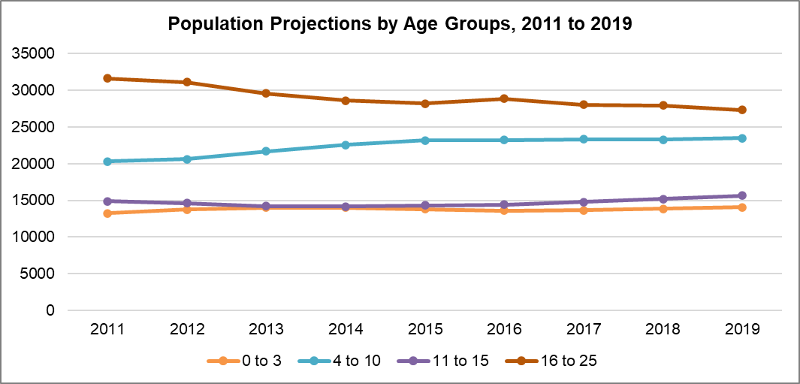
Source: GLA’s Harrow_scenario_2_BPO_2019

The number of 0 to 3 year olds in Harrow has fluctutated over the last decade, increasing from from 13,252 in 2011 to 14,023 in 2013 and then falling to 13,576 in 2016 but then increasing again to 14,048 in 2019. However, they are projected to decrease between 2019 and 2026, falling to 12,912 in 2026 and then very steadily increasing again to 13,382 in 2034.

Chart 2: Harrow’s 0 to 3 year old population
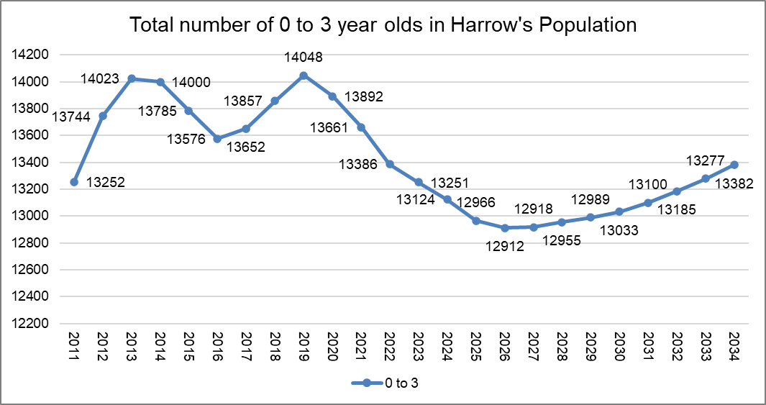
Source: GLA’s Harrow_scenario_2_BPO_2019

The number of 4 to 10 year olds has increased from 20,315 in 2011 to 23,469 in 2019, and are projected to dip to 23,135 in 2020 and then remain steady until 2026, after which they start to decrease to 21,866 by 2034, as can be seen in Chart 3 below.

Chart 3: Harrow’s 4 to 10 year old population
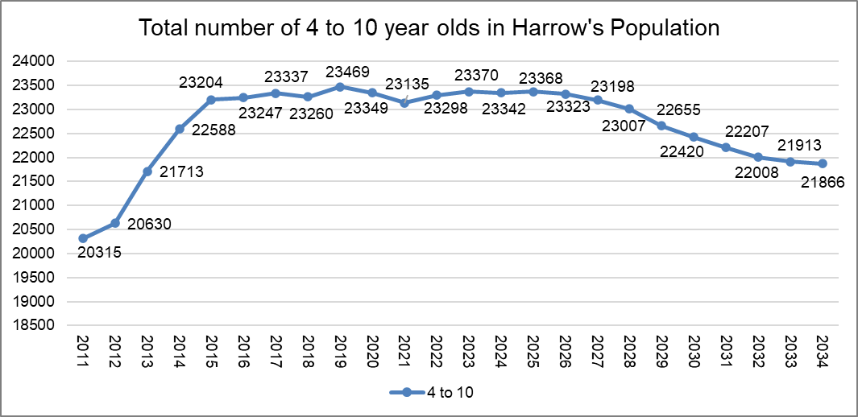
Source: GLA’s Harrow_scenario_2_BPO_2019

Chart 4 below shows that the number of 11 to 15 year olds decreased from 14,892 in 2011 to 14,160 in 2014, and then increased to 15,642 in 2019. The projections are projected to continue increasing peaking at 16,743 in 2025 and then remain steady with a downward trajectory to 16,081 in 2034.

Chart 4: Harrow’s 11 to 15 year old population
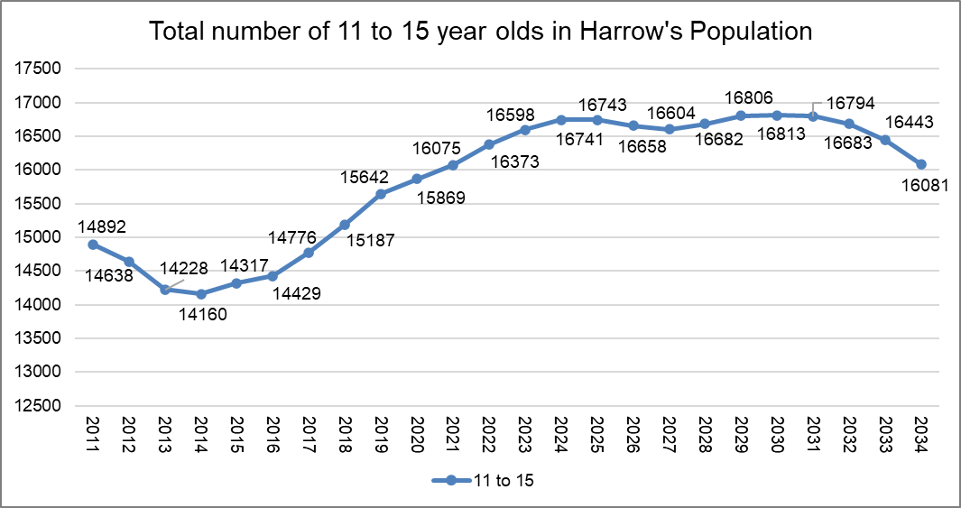
Source: GLA’s Harrow_scenario_2_BPO_2019

Chart 5 below shows that the number of 16 to 25 year olds has dropped from 31,644 in 2011 to 27,344 in 2019, and are projected to continue decreasing to 25,902 in 2021 and then steadily increase to 31,090 by 2034.

Chart 5: Harrow’s 16 to 25 year old population
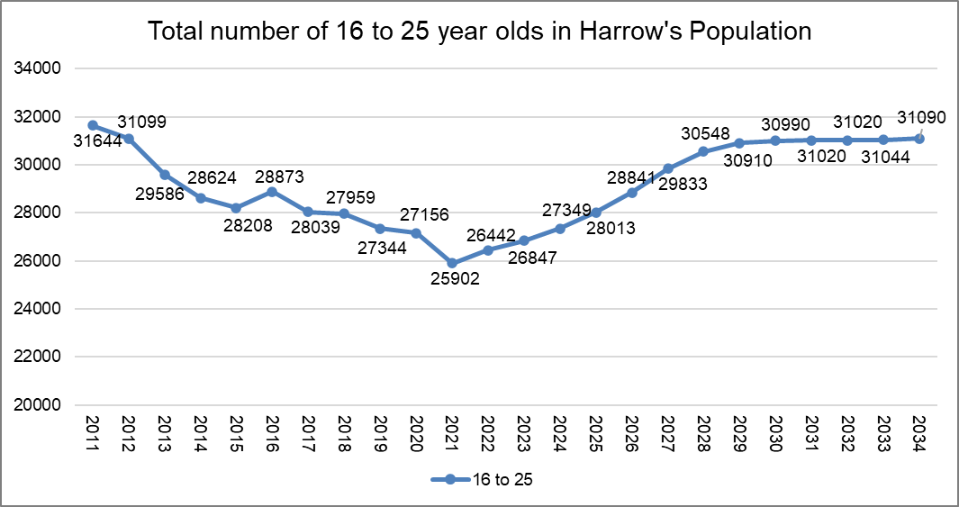
Source: GLA’s Harrow_scenario_2_BPO_2019
Primary Planning Areas
The GLA projections for primary schools are area based, using the Planning Areas created in 2004 by Harrow Council for school place planning when they were changed to reflect boundary changes. The projections for each Planning Area are based on a combination of ward-level child population projections and the historic pattern of subscription to schools. An analysis of where pupils went to school in 2004, based on pupils’ postcodes, was used to define the Planning Areas. Where over 40% of pupils in a ward went to schools in the Planning Area, these are described as “main” wards. Where between 10% and 40% of pupils in a ward went to schools in the Planning Area these are described as “other” wards. Thus, it is possible to see that for Planning Area 1, the North East, most pupils attending Aylward, Stanburn, Whitchurch and Weald Rise schools lived in Belmont, Stanmore Park and Canons wards. Smaller numbers of pupils lived in Harrow Weald, Edgware, Queensbury, Wealdstone, Kenton East and Kenton West. The Primary Planning Areas are a tool for school place planning and therefore there is consideration of the impact of changes in one planning area on another.

Following the changes that have just been made to Harrow’s ward boundary changes, which will be implemented in May 2022, Harrow’s Planning Areas will also be reviewed.

Harrow’s Births and Reception Year Rolls
Harrow’s observed births have continued to increase from 2,922 in 2005/06 to 3,620 in 2012/13, as can be seen in Chart 6 below. Births fluctuated from 2013/14 onwards - dropping to 3,509 in 2014/15, and increasing to 3,661 in 2015/16, then dropped again in 2016/17 to 3,624, but increased to 3,655 in 2017/18 and then fell again in 2019/20 to 3,506.

In-line with this decline Harrow’s projected births are projected to continue dropping, falling from 3,458 in 2020/21 to 3,276 in 2025/26, as can be seen in Chart 6 below.

Chart 6: Harrow’s Actual & Projected Births
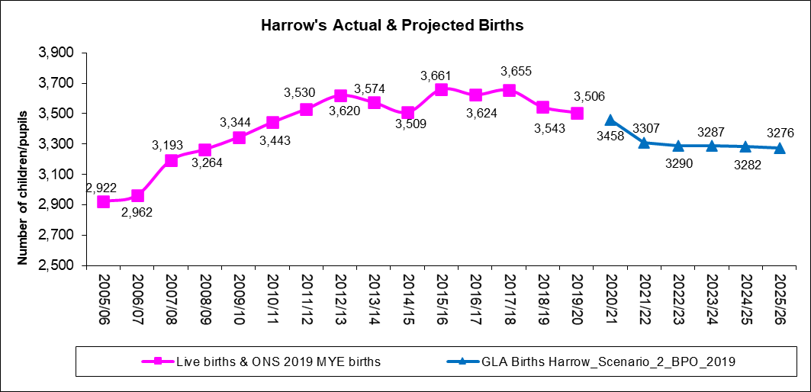
Source: GLA Births Harrow_scenario_2_BPO_2019

In-line with the increase in Harrow’s births Harrow schools’ actual Reception numbers increased from 2,224 in 2005/06 to 3,251 in 2014/15. However, the numbers fell in 2015/16 to 3,198 and then dropped again to 3,152 in 2016/17. In 2017/18 the reception number rose slightly to 3,191 but then dropped quite significantly to 3,044 in 2018/19, rose slightly to 3,079 in 2019/20 and then increased very slightly in 2020/21 to 3,089. This overall decline in the actual numbers is somewhat reflected in a lower trajectory of Harrow’s schools roll projections, as can be seen in chart 7 below. Due to this change this report includes both the school roll projections as provided by the GLA (referred to as baseline) alongside our local adjustment of 2%.

Chart 7: Harrow’s Actual & Projected Reception Year Rolls
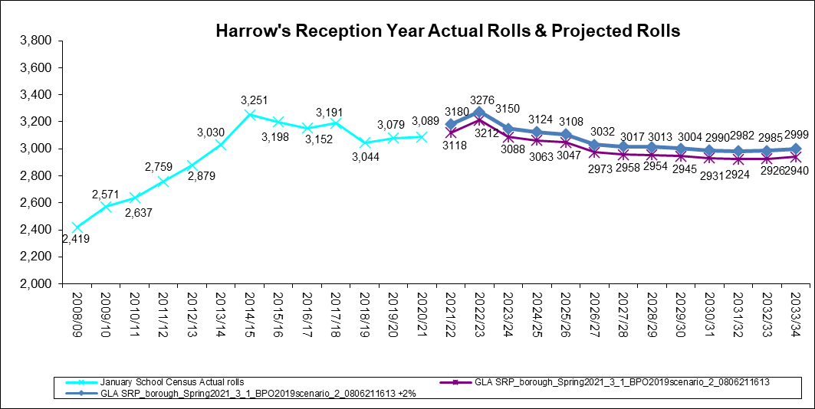
Source: GLA SRP_borough_Spring2021_3_1_BPO2019scenario_2_0806211613

Births to School Conversion
Harrow’s birth to school pupil conversion rate has ranged from 89% in 2006/07 (representing 2,310 children in Reception as at January 2007 from a total of 2,602 births in 2001/02) to 97% in 2014/15 (representing 3,251 children in Reception as at January 2015 from a total of 3,344 births in 2009/10). However the conversion rate has been dropping since and has fallen to 84% in 2020/21 (representing 3,089 children in Reception as at January 2020 from a total of 3,661 births).

It should be noted that increases in Harrow’s births have not inevitably translated into children accepting a place in Harrow’s schools Reception year group, as can be seen by the latest data above. There are likely to be a range of variables that will affect the actual number of births converting into Harrow’s Reception school children, such as migration into and out of the borough, migration out of the country especially of European Citizens returning to their country of origin (likely to be due to both Brexit and or the Covid-19 pandemic),children living on the borders of Harrow could be attending neighbouring boroughs school’s (especially with new free school’s opening in Harrow’s neighbouring boroughs), or even selecting an independent school.

Chart 9 below shows Harrow’s 2006/07 to 2019/20 births to actual Reception numbers on roll conversion rate, which has been fluctuating, from 89% in the academic year 2006/07, peaking at 97% in 2014/15, falling to 85% in 2018/19 and increasing to 88% in 2019/20 and then falling again to the lowest retention rate ever – 84% in 2020/21. It also shows Harrow’s 2020/21 to 2031/32 projected conversion rate, which is in line with the recent fluctuations in the actual conversion rates, ranging between 86% and 90%.

Chart 9 - Conversion rate of Harrow births into actual school Reception numbers on roll
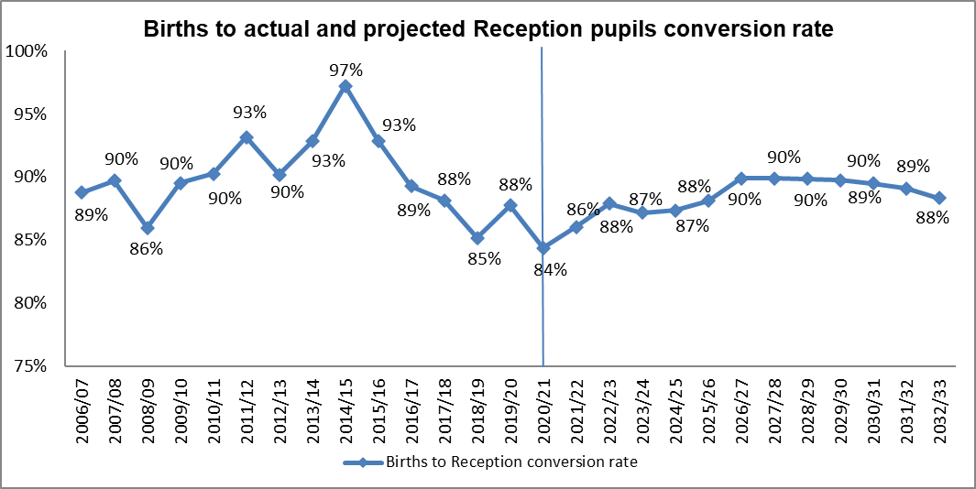
Source: GLA Births Harrow_scenario_2_BPO_2019

Section 2: Local Factors Influencing Harrow’s Pupil Projections

School Admissions Applications, Offers for Places and Take –Up

Residents must apply to their home authority for a maintained school place, whether the school place is within the authority or out of borough. During the Admissions process, applications for a Harrow school from out borough residents are also considered and vice versa. Whilst residents do not apply for an independent school place via the Local Authority, they sometimes do let the authority know that they are sending their child to an independent school.

Reception in-take
The Admissions service has experienced an increasing trend until 2014 in the number of on-time, late and in-year applications for Reception and all of the primary phase year groups. Applications for Reception places have platueaued from 2015 to 2020 and are now staring to decline.

Harrow Residents
Admissions received 3,142 applications (as at 18 July 2021) from Harrow residents for a September 2021 Reception year school place; this includes applications for Harrow schools, out of borough schools etc.

Applications and offers of Reception places
Table 1 below shows the total number of applications over the last few years. This table also illustrates the difference between the number of offers made and the take up of places as measured by the DfE School Census in January. The take-up rate has reverted back to previous years, falling slightly from last year’s rate and this will be monitored.

Table 1 – Admissions Reception Entry Applications of Harrow residents
Entry Year | On-time | Lates as at end of August | Total | Increase | % Increase from previous year | January Census | January Take Up Rate
 | January* | ** |  | (Total) |  | Reception
Sep-12 | 2,796 | 318 | 3,114 | - | - | 2,879 | 92.5%
Sep-13 | 2,991 | 330 | 3,321 | 207 | 6.65% | 3,029 | 91.2%
Sep-14 | 3,210 | 238 | 3,448 | 127 | 3.82% | 3,251 | 94.3%
Sep-15 | 3,126 | 288 | 3,414 | -34 | -0.99% | 3,195 | 93.6%
Sep-16 | 3,175 | 264 | 3,439 | 25 | 0.73% | 3,154 | 91.7%
Sep-17 | 3,143 | 243 | 3,386 | -53 | -1.54% | 3,189 | 94.2%
Sep-18 | 2,969 | 205 | 3,174 | -212 | -6.26% | 3,043 | 95.9%
Sep-19 | 2,976 | 212 | 3,188 | 14 | 0.44% | 3,079 | 96.6%
Sep-20 | 3,043 | 184 | 3,227 | 39 | 1.22% | 3,089 | 95.7%
Sep-21 | 2,864 | 278*** | 3,142 | -85 | -2.63% | 3,118 | 99.2%
* On-time applications are the data from the DfE returns submitted on offer day.
** Lates are the number of on-time applications subtracted from the total home (Harrow) applications on the Capita One system. (Note: if the home address of the pupil has changed to an address outside Harrow since the application, this may deflate the total number of late applications)
*** As at 18 July 2021

Year 7 intake

Harrow Residents
Admissions received 3,024 applications (as at 20 July 2021) from Harrow residents for a September 2020 year 7 school place; this includes applications for Harrow schools, out of borough schools and grammar schools etc.

Table 2 below shows the increase in the total number of applications over the last few years. It also illustrates the difference between the number of offers made and the take up of places as measured by the DfE School Census in January. The take-up rate remained at or just above 81% a few years ago, however it increased to 84.4% in September 2016, dropping slightly to 83.0% in September 2017, but then increased to 88.5% in September 2019. As at September 2020 the take up rate fell to 85.5%.

Table 2 – Admissions Year 7 Entry Applications of Harrow residents
Entry Year | On-time | Lates as at end of August(2) | Total | Increase | % Increase from previous year | January Census | January Take Up Rate
 | October(1) |  |  | (Total) |  | Year 7
Sep-13 | 2,329 | 129 | 2,458 | - | - | 1,982 | 80.6%
Sep-14 | 2,475 | 167 | 2,642 | 184 | 7.49% | 2,160 | 81.8%
Sep-15 | 2,557 | 167 | 2,724 | 82 | 3.10% | 2,204 | 80.9%
Sep-16 | 2,676 | 142 | 2,818 | 94 | 3.45% | 2,377 | 84.4%
Sep-17 | 2,753 | 75 | 2,828 | 10 | 0.35% | 2,347 | 83.0%
Sep-18 | 2,749 | 139 | 2,888 | 60 | 2.12% | 2,534 | 87.7%
Sep-19 | 2,914 | 104 | 3,018 | 130 | 4.50% | 2,670 | 88.5%
Sep-20 | 2,986 | 83 | 3,069 | 51 | 1.69% | 2,623 | 85.5%
Sep-21 | 2,931 | 93 | 3,024(3) | -45 | -1.47% | 2,668 | 88.2%
(1) On-time applications are the data from the DfE returns submitted on offer day.
(2) Lates are the number of on-time applications subtracted from the total home (Harrow) applications on EMS. (Note: if the home address of the pupil has changed to an address outside Harrow since the application, this may deflate the total number of late applications)
(3) As at 20 July 2021

Harrow primary schools’ pupils’ borough of residence
The number of pupils in Reception to Year 6 in Harrow schools have consistently increased since 2005/06 (16,633) to 2019/20 (21,714). However the number dropped for the first time in January 2021 - there were 21,480 pupils in Harrow’s 39 primary and 1 all through school, a drop of 234 pupils. (Source: Harrow schools’ school census).

The number of out of borough primary age pupils attending Harrow’s schools also increased, from 2,031 in January 2016, to 2,125 in January 2017 to 2,200 in January 2018 and 2,301 in January 2019, however they dropped to 2,299 in 2020 and 2,261 in 2021.

Table 3 below shows that as at January 2021 the majority of Harrow’s primary school pupils reside within the borough of Harrow.

Table 3: Harrow schools’ Reception to Year 6 pupils Harrow ward of residence
January 2021 & (January 2020)
Ward | Number of pupils | Percentage of pupils
Roxbourne | 1242 (1275) | 5.8% (5.9%)
Marlborough | 1242 (1228) | 5.8% (5.7%)
Greenhill | 1240 (1232) | 5.8% (5.7%)
Wealdstone | 1204 (1223) | 5.6% (5.6%)
Queensbury | 1062 (1046) | 4.9% (4.8%)
Edgware | 986 (1023) | 4.6% (4.7%)
Pinner South | 950 (985) | 4.4% (4.5%)
Headstone South | 950 (989) | 4.4% (4.6%)
Belmont | 924 (945) | 4.3% (4.4%)
Rayners Lane | 901 (972) | 4.2% (4.5%)
Harrow Weald | 873 (912) | 4.1% (4.2%)
Kenton East | 873 (880) | 4.1% (4.1%)
Headstone North | 863 (761) | 4.0% (3.5%)
West Harrow | 845 (838) | 3.9% (3.9%)
Kenton West | 818 (788) | 3.8% (3.6%)
Roxeth | 786 (772) | 3.7% (3.6%)
Harrow on the Hill | 772 (828) | 3.6% (3.8%)
Canons | 729 (725) | 3.4% (3.3%)
Hatch End | 688 (722) | 3.2% (3.3%)
Stanmore Park | 639 (654) | 3.0% (3.0%)
Pinner | 632 (617) | 2.9% (2.8%)
Harrow wards total | 19219 (19415) | 89.5% (89.4%)
Out of borough | 2261 (2299) | 10.5% (10.6%)
Grand total | 21480 (21714) | 100% (100%)
Source – January 2020 & 2021 School Census NB special schools not included

Residence of Reception Pupils
As at January 2021 there were 3,089 (3,079 in 2020) pupils in the Reception year group and 9.7% (9.0% in 2020) of Harrow schools’ Reception pupils live outside the borough. In January 2021 outborough pupils mainly live in Harrow’s neighbouring boroughs: Brent 111 (108 in 2020), Hillingdon 67 (67 in 2020), Ealing 36 (33 in 2020) and Barnet 35 (27 in 2020), Other LAs 50 (41 in 2020).

DfE’s Primary Cross Border Movement
In January 2020, 6.5% (7.6% in January 2019) of Harrow’s resident Reception age children attended schools maintained by other local authorities. The net difference between imports and exports as a percentage of the school population in Reception for Harrow in 2019/20 is 0%, as 6.5% of other local authorities children attended schools in Harrow.

The numbers of primary age pupils exported and imported into Harrow have remained similar and balanced over the last 4 years; however as at January 2020 Harrow imported 541 (501 in January 2019) more children into its schools than it exported into other borough’s schools.

Table 4 below shows where Harrow’s resident pupils attend primary schools outside of the borough over the last 4 years. The number of pupils leaving Harrow to attend schools in other boroughs has continued dropping over the last four years, from 1,932 in January 2016 to 1,715 in January 2020.

Table 4: Harrow’s resident pupils attending primary schools in other boroughs
Primary School LA | Pupil residents of Harrow
 | Jan-17 | Jan-18 | Jan-19 | Jan-20
Primary Schools in Hillingdon | 659 | 621 | 567 | 538
Primary Schools in Brent | 521 | 514 | 501 | 500
Primary Schools in Barnet | 431 | 419 | 398 | 385
Primary Schools in Ealing | 155 | 147 | 164 | 160
Primary Schools in Hertfordshire | 110 | 124 | 114 | 85
Other LAs | 44 | 47 | 51 | 47
Total Harrow resident pupils exported | 1,920 | 1,872 | 1,795 | 1,715
Source: DfE SFR Cross Border Movement

Table 5 below shows the number of out of borough of residents attending Harrow’s primary schools. The number of out of borough pupils attending Harrow’s schools increased from 2,060 in January 2017 to 2,296 in January 2019 but dropped slightly to 2,256 in 2020.

Table 5: Borough of residence of Harrow’s primary school pupils
LA Name Residence | Primary School in Harrow
 | Jan-17 | Jan-18 | Jan-19 | Jan-20
Residents of Brent | 711 | 743 | 789 | 786
Residents of Hillingdon | 418 | 441 | 499 | 498
Residents of Hertfordshire | 368 | 384 | 450 | 418
Residents of Ealing | 307 | 296 | 297 | 283
Residents of Barnet | 205 | 204 | 211 | 223
Other LAs | 42 | 36 | 48 | 48
Unknown* | 9 | 6 | 2 | 6
Total out of borough pupils imported | 2,060 | 2,110 | 2,296 | 2,256
Source: DfE SFR Cross Border Movement
* Includes pupils with invalid postcodes

Harrow secondary schools’ pupils’ borough of residence
As at January 2021, there were 12,836 pupils on roll (12,458 pupils in January 2020) in Years 7 to 11 in Harrow’s 12 secondary and 1 all through schools.

The number of out of borough secondary aged pupils attending Harrow schools has continued to increase from 2,048 in January 2017 to 2,511 in January 2021, a 23% increase.

January | 2017 | 2018 | 2019 | 2020 | 2021
OoB pupils | 2,048 | 2,134 | 2,335 | 2,468 | 2,511

Table 6 below shows that a majority of Harrow’s high school pupils reside in the borough of Harrow. In Harrow the higher number of pupils live in following wards - Wealdstone 746 (5.8%), Roxbourne 699 (5.4%) and Marlborough 652 (5.1%) wards, whereas less than 300 pupils live in Hatch End 274 (2.1%) and Pinner 203 (1.6%). The highest number of pupils living outside the borough reside in Brent – 865, 6.7%.

Table 6: Harrow schools’ Year 7 to Year 11 pupils Harrow ward of residence
January 2021 (January 2020)
Ward | Number of pupils | Percentage of pupils
Wealdstone | 746 (740) | 5.8% (5.9%)
Roxbourne | 699 (703) | 5.4% (5.6%)
Marlborough | 652 (611) | 5.1% (4.9%)
Harrow Weald | 606 (559) | 4.7% (4.5%)
Queensbury | 594 (594) | 4.6% (4.8%)
Headstone South | 586 (556) | 4.6% (4.5%)
Edgware | 576 (583) | 4.5% (4.7%)
Belmont | 540 (538) | 4.2% (4.3%)
West Harrow | 502 (476) | 3.9% (3.8%)
Greenhill | 487 (459) | 3.8% (3.7%)
Harrow on the Hill | 486 (453) | 3.8% (3.6%)
Roxeth | 481 (512) | 3.7% (4.1%)
Headstone North | 473 (447) | 3.7% (3.6%)
Rayners Lane | 452 (421) | 3.5% (3.4%)
Canons | 409 (402) | 3.2% (3.2%)
Kenton West | 406 (400) | 3.2% (3.3%)
Stanmore Park | 392 (372) | 3.1% (3.0%)
Kenton East | 382 (379) | 3.0% (3.0%)
Pinner South | 379 (345) | 3.0% (2.8%)
Hatch End | 274 (264) | 2.1% (2.1%)
Pinner | 203 (176) | 1.6% (1.4%)
Harrow wards total | 10,325 (9990) | 80.4% (80.2%)
Out of borough | 2,511 (2468) | 19.6% (19.8%)
Grand Total | 12,836 (12458) | 100% (100%)
Source – January 2019 & 2020 School Census. NB special schools not included.

Residence of Year 7 pupils
As at January 2021 there were 2,623 (2,670 in 2020) pupils on roll in Year 7, of these pupils 480 do not live in Harrow, and a majority of them live in Harrow’s neighbouring boroughs, 154 in Brent, 116 in Ealing, 76 in Hillingdon, 65 in Barnet and 69 in other LAs.

DfE Secondary Cross Border Movement
As at January 2020 the number of secondary age pupils exported from Harrow was 3,640 (January 2019 – 3,747) and the number imported into Harrow’s high schools was only 2,468 (January 2019 – 2,359), resulting in a loss of 1,169 pupils (January 2019 – 1,388). This is lower than the loss in January 2017 of 1,435 resident pupils, 1,528 in January 2016 and 1,554 loss in January 2015.

There was a 3% reduction (107 pupils) in the number of Harrow’s resident pupils attending high schools in another borough (3,747 in January 2019 to 3,637 in January 2020). The table below shows where Harrow’s resident pupils have gone to high schools outside of the borough over the last 4 years.

Table 7: Harrow’s resident pupils attending high schools in other boroughs
High School LA | Pupil residents of Harrow
 | Jan-17 | Jan-18 | Jan-19 | Jan-20
High Schools in Hillingdon | 836 | 836 | 868 | 868
High Schools in Brent | 821 | 862 | 893 | 862
High Schools in Hertfordshire | 759 | 824 | 841 | 828
High Schools in Barnet | 739 | 706 | 699 | 647
High Schools in Buckinghamshire | 116 | 143 | 128 | 100
High Schools in Ealing | 86 | 110 | 92 | 94
High Schools in Slough | 84 | 84 | 80 | 87
High Schools in Hammersmith & Fulham | 63 | 54 | 54 | 49
Other LAs | 77 | 88 | 92 | 105
Total Harrow resident pupils exported | 3,581 | 3,707 | 3,747 | 3,640
Source: DfE SFR Cross Border Movement

Table 8 below shows the number of out of borough residents attending Harrow’s high schools over the last 4 years. This number has increased from 2,148 in January 2017 to 2,468 in January 2020, which represents a 14.9% (320 pupils) increase from January 2018 to January 2019.

Table 8: Borough of residence of Harrow’s high school pupils
LA Name Residence | High Schools in Harrow
 | Jan-17 | Jan-18 | Jan-19 | Jan-20
Residents of Brent | 976 | 972 | 935 | 911
Residents of Ealing | 384 | 419 | 492 | 542
Residents of Barnet | 377 | 393 | 427 | 413
Residents of Hillingdon | 172 | 197 | 254 | 306
Residents of Hertfordshire | 188 | 225 | 194 | 231
Unknown* | 2 | 6 | 6 | 5
Other LAs | 49 | 54 | 51 | 60
Total out of borough pupils imported | 2,148 | 2,266 | 2,359 | 2,468
Source: DfE SFR Cross Border Movement
* Includes pupils with invalid postcodes

Transferral rate of Harrow primary school pupils to Harrow secondary schools
The number of pupils in Year 6 has been increasing over the last few years, with latest numbers at 3,038 as at January 2020 (2,972 as at May 2019). The percentage of Year 6 pupils that have transferred to Year 7 in Harrows’ high schools has stayed steady between 66% and 70% over the last 8 years, with this year’s rate at 68.7%. The remainder of the year 6 pupils are likely to be leaving a Harrow primary school to attend an independent school or a state school in another borough including maintained, voluntary aided and grammar schools. Table 9 below shows the Year 6 to Year 7 transferral rates for the last 11 years.

Table 9: Proportion of Harrow’s Primary School Year 6 pupils (as at the May school census) transferring across to Year 7 in Harrow’s High Schools (as at the October school census)
School Census | Total Yr 6* in Harrow primary schools as at School Census | October School Census | No. of Harrow primary school Yr 6 pupils transferring to Yr 7 in Harrow's high schools as at October School Census* | % transferring | Yr 7 Number* on Roll as at October School Census
May-10 | 2,394 | Oct-10 | 1,709 | 71.4% | 1,972
May-11 | 2,408 | Jan-12** | 1,716 | 71.6% | 2,088
May-12 | 2,333 | Oct-12 | 1,559 | 67.4% | 1,861
May-13 | 2,395 | Oct-13 | 1,592 | 67.1% | 1,980
May-14 | 2,545 | Oct-14 | 1,697 | 66.7% | 2,172
May-15 | 2,597 | Oct-15 | 1,721 | 66.3% | 2,198
May-16 | 2,711 | Oct-16 | 1,783 | 65.8% | 2,371
May-17 | 2,761 | Oct-17 | 1,844 | 66.7% | 2,348
May-18 | 2,791 | Oct-18 | 1,892 | 67.8% | 2,512
May-19 | 2,972 | Oct-19 | 2,072 | 69.7% | 2,659
Jan-20*** | 3,038 | Oct-20 | 2,088 | 68.7% | 2,618
*The numbers on roll do not include special school pupils;
**The October 2011 data was not available for Academies, so the January 2012 school census was used instead.
***The May 2020 school census was not collected due to the Covid-19 pandemic.

Retention rate of Harrow secondary schools
The number of pupils in Year 7 in Harrow’s secondary schools in October 2020 dropped to 2,618 from 2,659 in October 2019. The retention rate is calculated as percentage by comparing the number of pupils on roll in Year 7 in the October census to that of to the number of pupils on roll in Year 6 in the May census. The retention rate of pupils that are on roll in Year 7 compared to pupils who are on roll in Year 6 has been over 85% during the last 6 years. In October 2020 there were 2,618 pupils on roll which is 86% of the number of pupils on roll in January 2020 in Year 6. Please see table 10 below.

Table 10: Year 7 Retention Rates
May School Census* | Yr 6 | October School Census* | Yr 7 | Yr 7 as % of previous Yr 6
May-10 | 2,394 | Oct-10 | 1,972 | 82%
May-11 | 2,408 | Jan-12** | 2,088 | 87%
May-12 | 2,333 | Oct-12 | 1,861 | 80%
May-13 | 2,395 | Oct-13 | 1,980 | 83%
May-14 | 2,545 | Oct-14 | 2,172 | 85%
May-15 | 2,597 | Oct-15 | 2,198 | 85%
May-16 | 2,711 | Oct-16 | 2,371 | 87%
May-17 | 2,761 | Oct-17 | 2,348 | 85%
May-18 | 2,791 | Oct-18 | 2,512 | 90%
May-19 | 2,972 | Oct-19 | 2,659 | 89%
Jan-20 | 3,038 | Oct-20 | 2,618 | 86%
*The numbers on roll do not include special school pupils;
**The October 2011 data was not available for Academies, so the January 2012 school census was used instead.
***The May 2020 school census was not collected due to the Covid-19 pandemic.

If you compare the transfer rate in table 9 and the retention rate in table 10, this indicates that some of the 30% of pupils who did not transfer at the end of Year 6 from a Harrow Primary School into Year 7 of a Harrow secondary school are replaced by children from outside the borough. The retention rate will be monitored closely to identify any emerging trends arising as a result of changes to secondary school provision in Harrow with the opening of new and additional secondary places.

